**Recitation 4 – Student T-tests**

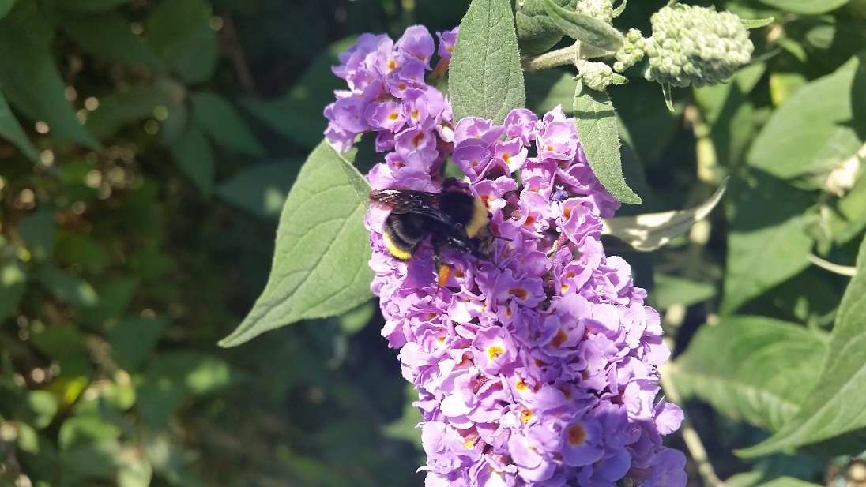

-------- Exercise 1. ---------

**Problem:** Biologists at Tufts and UC Davis were interested in whether worker size varies significantly among colonies in the yellow faced bumble bee (*Bombus vosnesenskii,* pictured). Bumble bee workers can vary up to 10-fold in mass and they exhibit a phenomenon called size polyethism, where task allocation is determined based on worker size.

1. If the population mean (mu) for bumble bee forager size (ITS) is 3.81, do you think your sample is representative of the whole population? In other words, are the population and sample means similar? If not, is your sample greater or less than the population mean?
2. Are the sample means for foraging worker size for colony 41 and colony 43 different from each other? If not, which colony has greater bumble bee worker size (report p-value)?
   * Repeat question 2 for colony 32 and colony 2.
3. Calculate the mean, standard deviation, standard error, and confidence intervals for forager size for each colony, except Colony 22. [**Hint:** dplyr might be good here]
4. Create three barplots for mean body size (ITS) for each colony (excluding colony 22) with error bars representing (i) standard deviation, (ii) standard error and (iii) 95% confidence intervals. [**HINT:** use arrows() function for creating error bars]

-------- Exercise 2. ---------

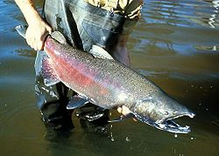**Problem:** Biologists were interested in whether brook trout (native to Eastern North America) that were introduced to the Pacific Northwest affects the survival of the native chinook salmon (pictured).

1. Does the presence or absence of introduced trout affect the proportion of chinook salmon surviving?
2. Create three barplot for mean proportion surviving for both treatments with error bars representing (i) standard deviation, (ii) standard error and (iii) 95% confidence intervals.